1. **Agenda**: <https://github.com/in28minutes/MockitoTutorialForBeginners/blob/master/Step04.md>
   1. 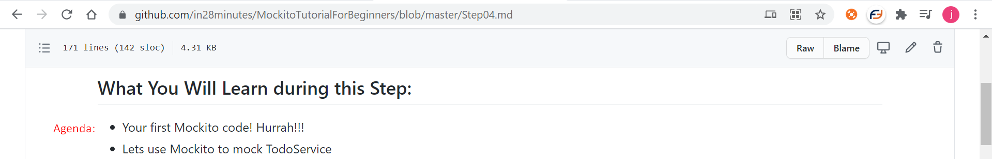
2. Text

   Description automatically generated with low confidence
3. Text

   Description automatically generated with medium confidence
4. Graphical user interface, text, application

   Description automatically generated
5. Let’s mock instead of stubbing now.  
   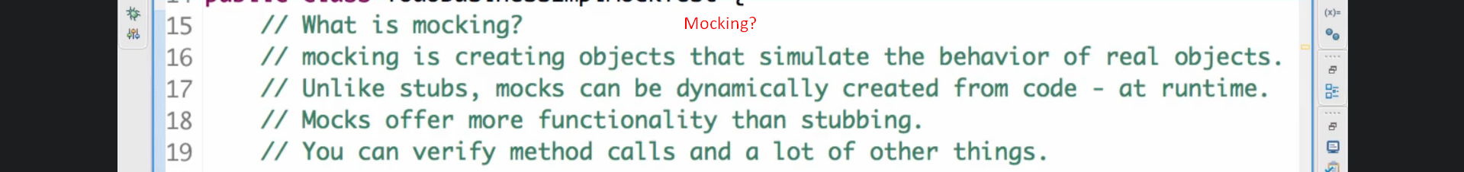
6. **NOTE**: **Mockito** offers other functionalities too apart from stubbing. We will talk about those later on.
7. Creating first mock object.  
   Text

   Description automatically generated
8. Let’s see the class from which this mock object was created. Graphical user interface, application

   Description automatically generated
9. Graphical user interface, text, application

   Description automatically generated
10. **Let’s define the return value for method on a mock object.**
    1. **NOTE**: **when**() is used to stub a method.
    2. Graphical user interface, text, application

       Description automatically generated
    3. Graphical user interface, text, application, chat or text message

       Description automatically generated